Antarctic Meteorological Research and Data Center Dataset Development & Stewardship Project

For

Near-term Variability and Prediction of the Antarctic Climate System AntCLIM^{now} Project
Scientific Committee on Antarctic Research (SCAR)

October 4, 2022

Matthew A. Lazzara and Matthew G. Noojin
Antarctic Meteorological Research and Data Center
Department of Physical Sciences
School of Engineering, Science and Mathematics
Madison Area Technical College
1701 Wright Street
Madison, Wisconsin, USA 53704
Voice: +1 (608) 616-3382
FAX: +1 (608) 243-4027

http://amrdcdata.ssec.wisc.edu
http://amrc.ssec.wisc.edu
https://madisoncollege.edu/antarctic-meteorology-project
mlazzara@madisoncollege.edu
mnoojin@madisoncollege.edu

UW SSEC Publication No.22.10.L1.

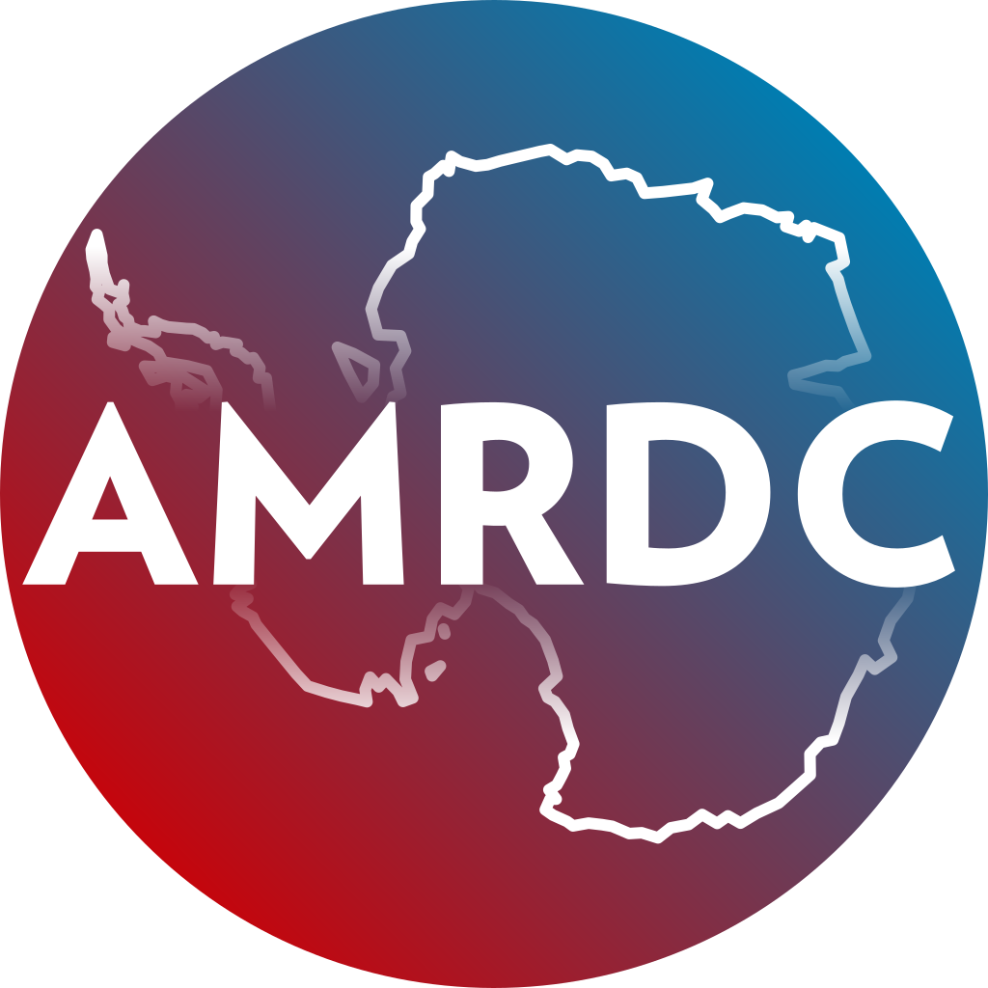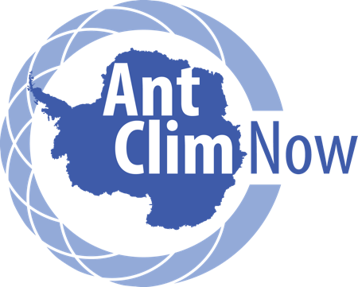

Compiled in 2022 by the
Antarctic Meteorological Research and Data Center
Department of Physical Sciences
School of Engineering, Science and Mathematics
Madison Area Technical College

Material in this document may be copied without restraint for library, abstract service, educational, or personal research purposes.

This report may be cited as:

Lazzara, M.A., and M.G. Noojin 2022: Antarctic Meteorological Research and Data Center Dataset Development & Stewardship Project Antarctic Meteorological Research and Data Center Department of Physical Sciences School of Engineering, Science and Mathematics, UW SSEC Publication No.22.10.L1. pp. [Available from The Schwerdtfeger Library, University of Wisconsin-Madison, 1225 W. Dayton St., Madison, WI 53706.]

This report is available from:

The Schwerdtfeger Library
University of Wisconsin-Madison
1225 W. Dayton St., Madison, WI 53706
UW SSEC Publication No.22.10.L1
(http://library.ssec.wisc.edu/).

Or on-line at:

https://amrdcdata.ssec.wisc.edu/

Project Summary

There are several institutions around the world that host and offer Antarctic meteorological datasets, with no clearinghouse that links them together. Hence, the SCAR Scientific Research Program, Near-term Variability and Prediction of the Antarctic Climate System (AntClimNow) has a major goal of improving access and coordination of Antarctic climate and meteorological data. This project aids those seeking Antarctic meteorological data and to specifically support the AntClim^{Now} data stewardship and scientific research program by linking disparate archives and data holdings into the newly developed Antarctic Meteorological Research and Data Center (AMRDC) Repository (https://amrdcdata.ssec.wisc.edu/).

Project Status

As of 30 September 2022, the AMRDC has accomplished the following tasks:

- A total of 91 datasets have been linked into the AMRDC Data Repository
- A specific project collection has been made for this effort:
  - https://amrdcdata.ssec.wisc.edu/group/antclimnow-project
and the new AntCLIM^{now} collection can be found on this page:
  - https://amrdcdata.ssec.wisc.edu/group
- All newly linked datasets are available via general and advanced search in the AMRDC Data Repository
- An additional 72 datasets have been identified and will be added to the AMRDC Data Repository in the near future

While a few examples continue the actual data, external data links are denoted in the records. For example:

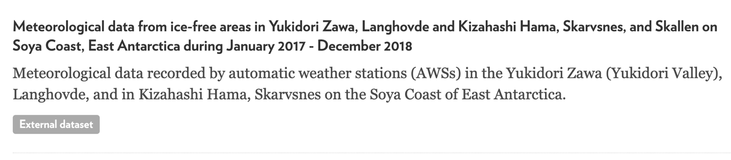

This dataset, has a full entry in the AMRDC repository:

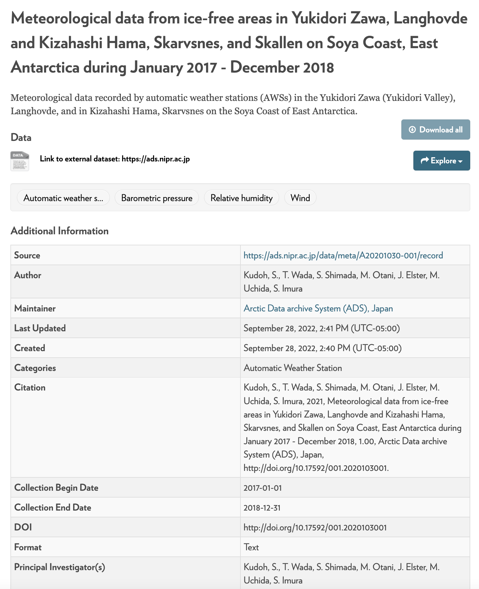

Both locations provide direct links to the original data repository where this data resides. To date, over 91 datasets from research organization across 5 continents are now linked into the repository

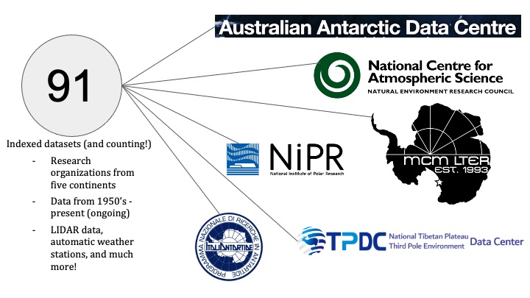

Below is a geographical coverage map that reveals the current holdings in the repository. Green crosses are datasets linked and indexed in the AMRDC repository as a part of this project:

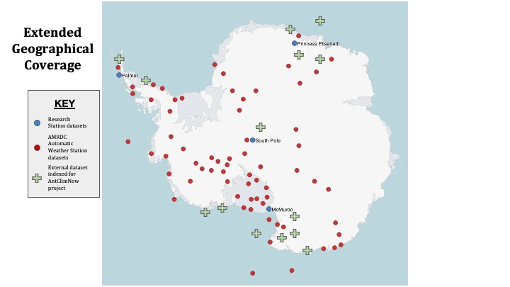

Future Plans

This effort will have a goal of continuing this work into the future. As external datasets are identified, they will be added to the AMRDC Data Repository collection. Some specific repositories will watched for new data including the United States Antarctic Program Data Center (USAP-DC; https://www.usap-dc.org/). Overall, this will be an on-going effort.

One challenge we have discovered is the availability of datasets that do not completely have a full set of metadata. This ends up leaving only a partial metadata record in the AMRDC archive. While this is unfortunate, it is of greater value to the community to have a partial entry, than none at all.

The funded effort here will be included in all presentations on the AMRDC including at the recently held Workshop on Antarctic Meteorology and Climate & American Meteorological Society’s Polar Meteorology and Oceanography Meeting. Future meetings and workshops, moving forward, we will present our work here as well with our AMRDC data repository efforts.

Acknowledgements

The authors wish to thank Tom Bracegirdle and Ilana Wainer for their support of this project. Special thanks to Irina Gorodetskaya for her encouragement and enthusiasm for our work here at the AMRDC.

